**Weekly Task(16-02-2024)**

1. Create a html page with all heading tags and anchor tags with one table and form as shown in below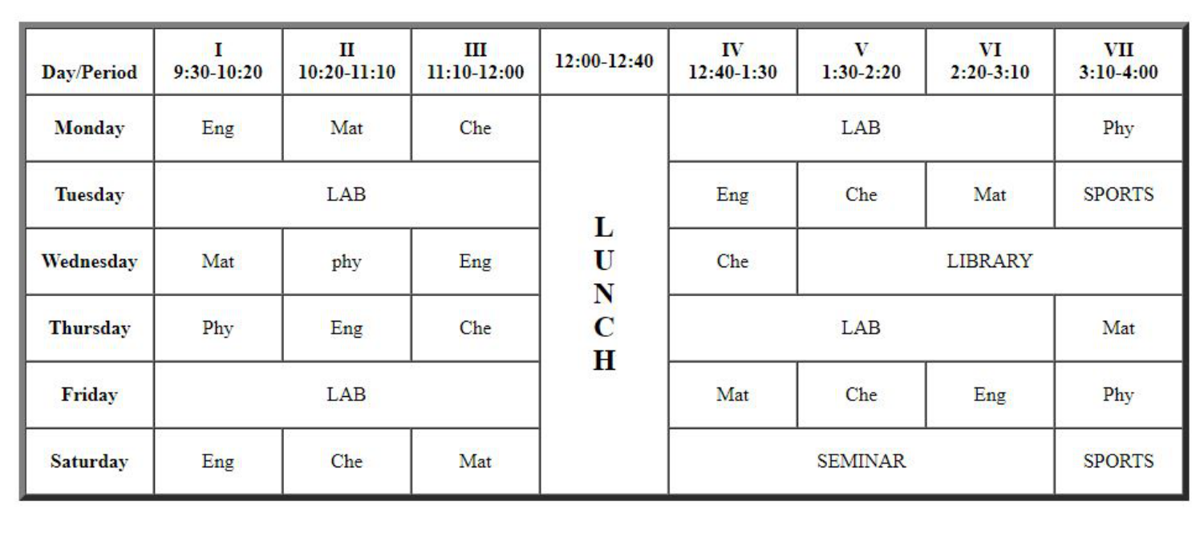
2. 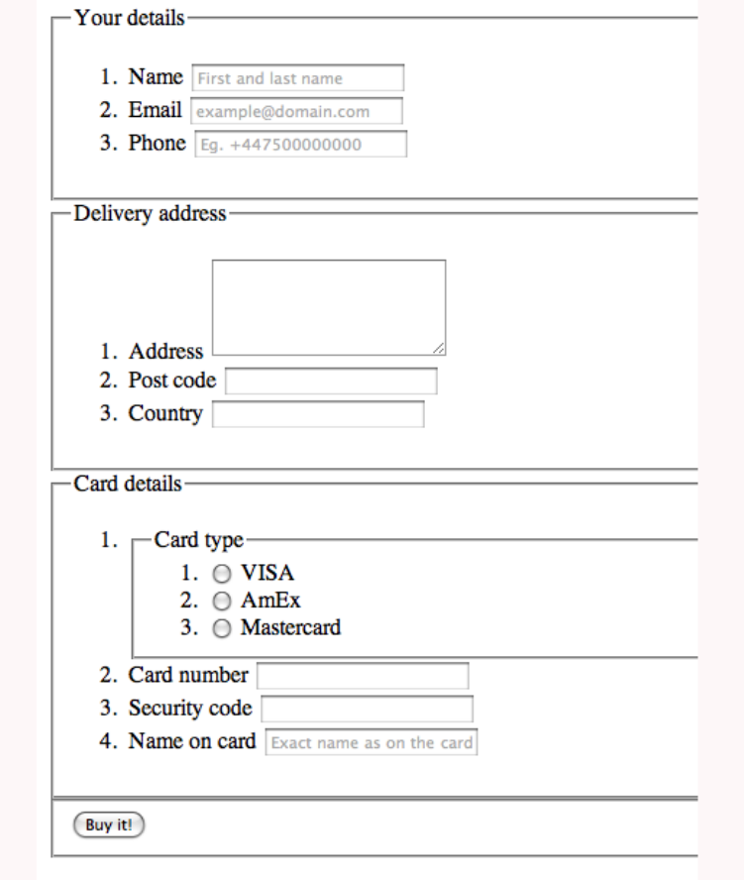  
   in this form add checkboxes with hobbies and states select options. Search and use fieldset and legend for border around the forms.

<fieldset>

<legend> your details</legend>

<form>

<input />

</form>

</fieldset>

1. And display like below image

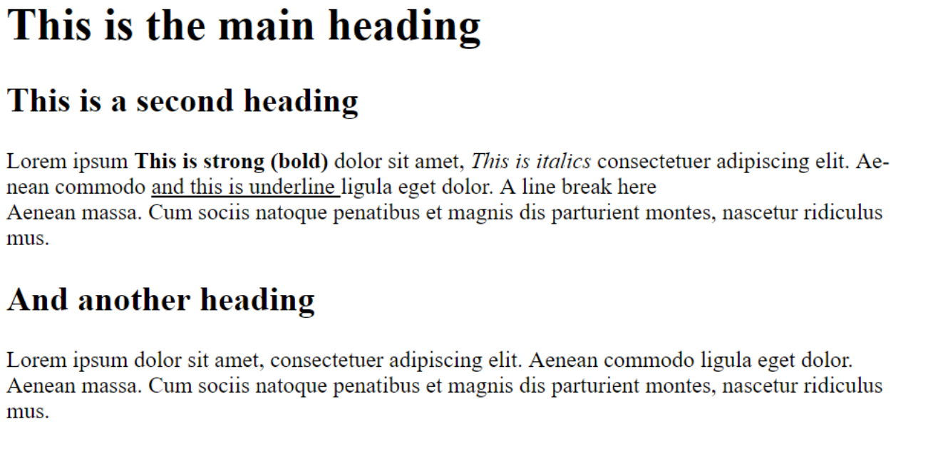

1. Display elements like below image using anchor tags and add image also

